1. Configure 2 slave machines in jenkins master.

Create 3 ec2 instances ; master, slave01 and slave-02 and install Jenkins in master

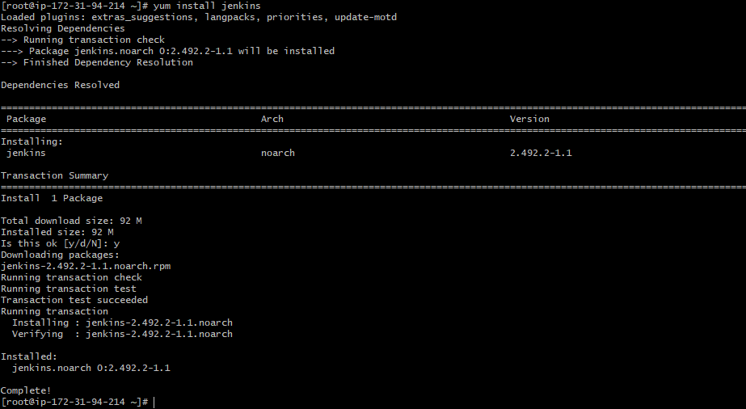

After giving the specific configuration we can see the Jenkins gui

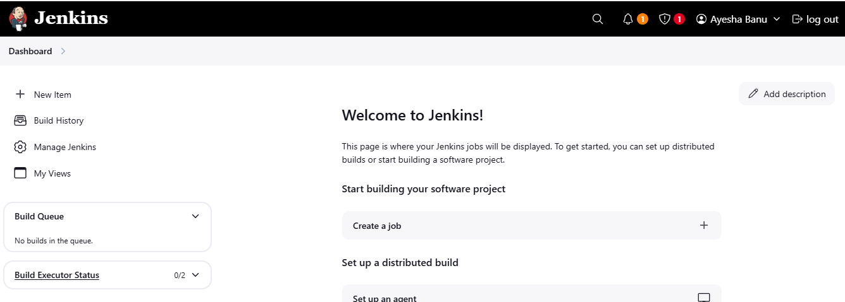

Install java in slave-01

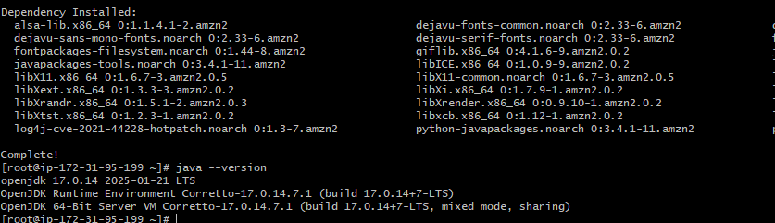

Install java in slave-02

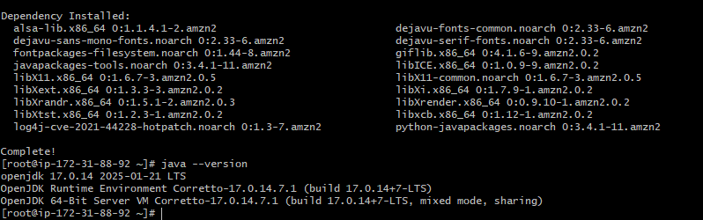

Step -02 :- create a ssh-keygen

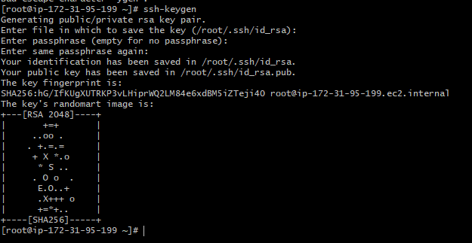

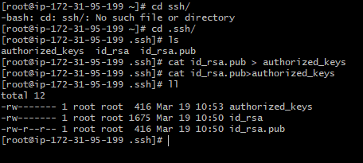

Giving the permission to the authorized_key and creating the workspace in slave01

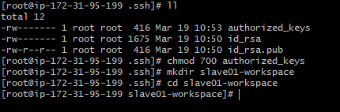

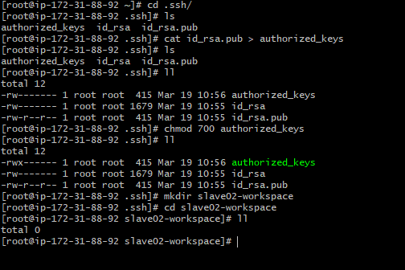

For slave 01

We need to give a command to copy the key from the slave01

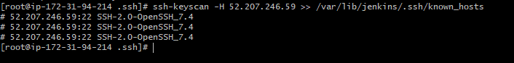

We need to change a permission for the known_hosts file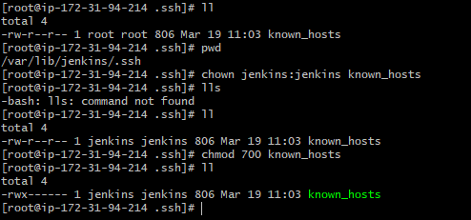

For slave -02

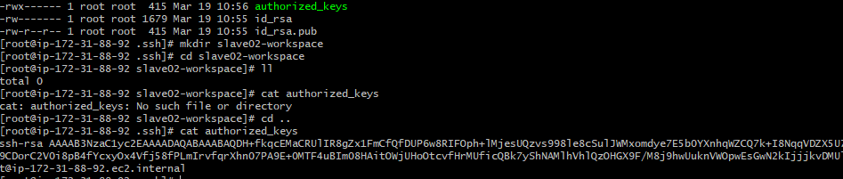

In Jenkins, goto Dashboard🡪 Manage Jenkins🡪nodes🡪create node

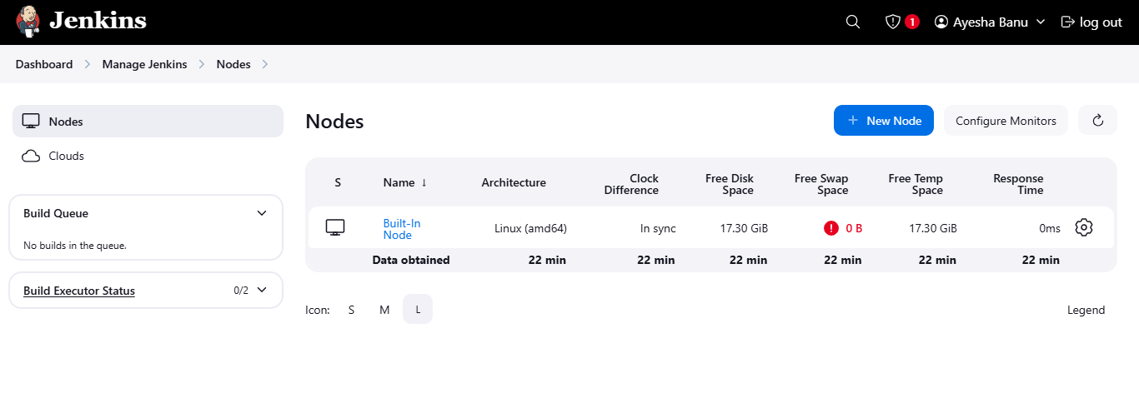

Give the name and select type 🡪 permanent agent🡪create

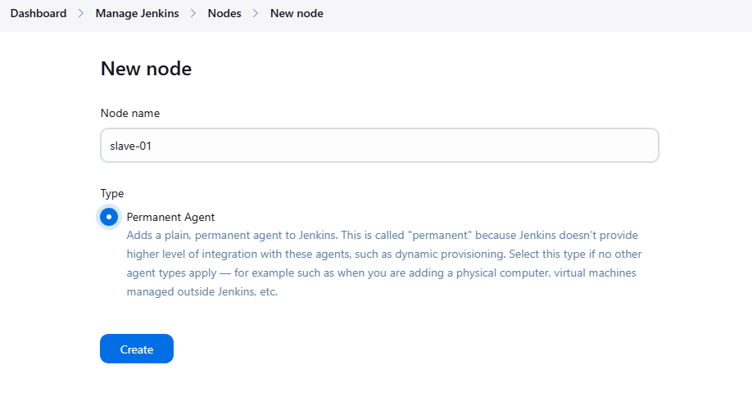

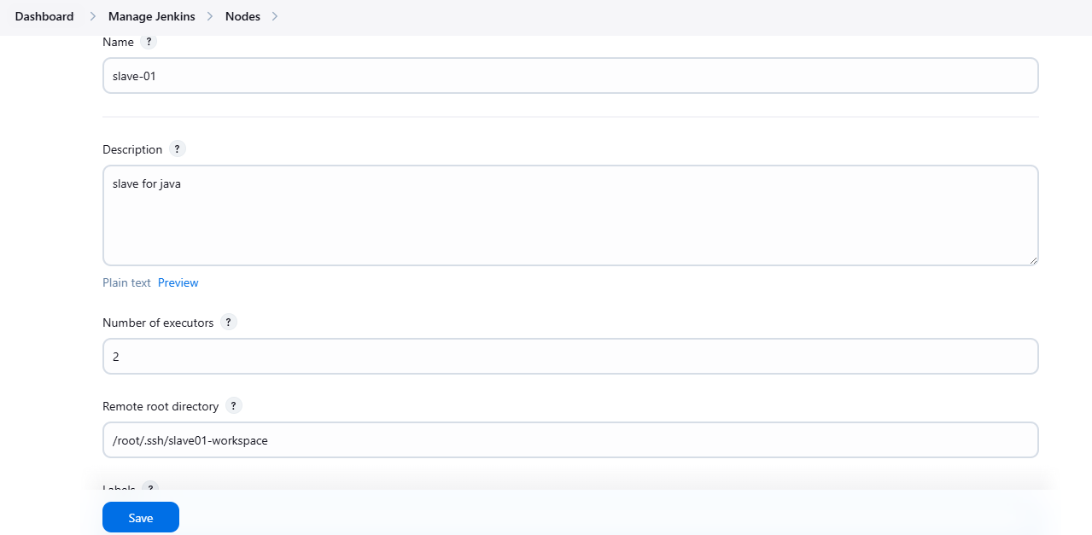

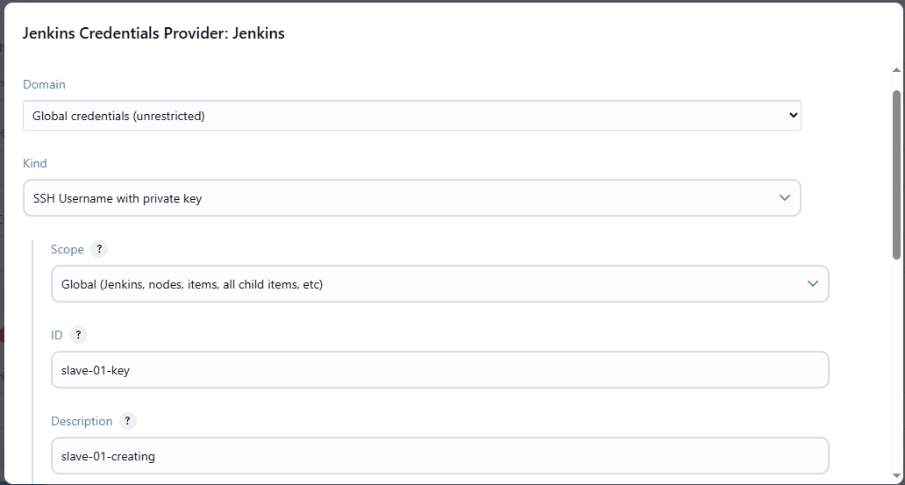

Need to pass the pem key in the key feild

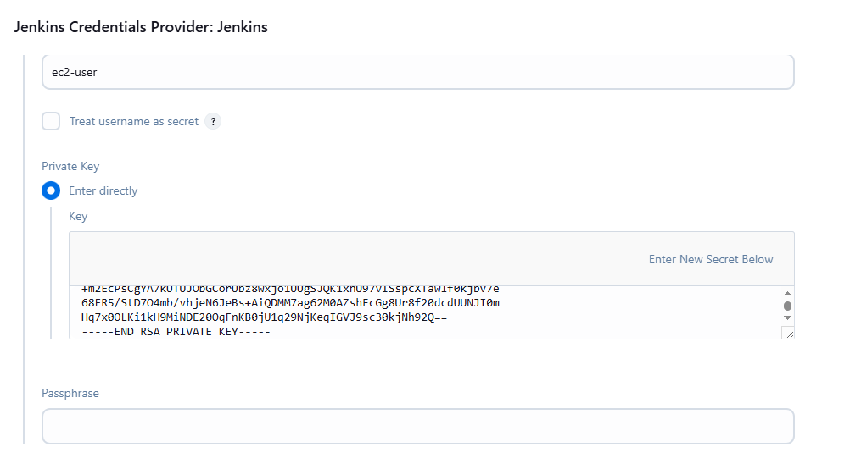

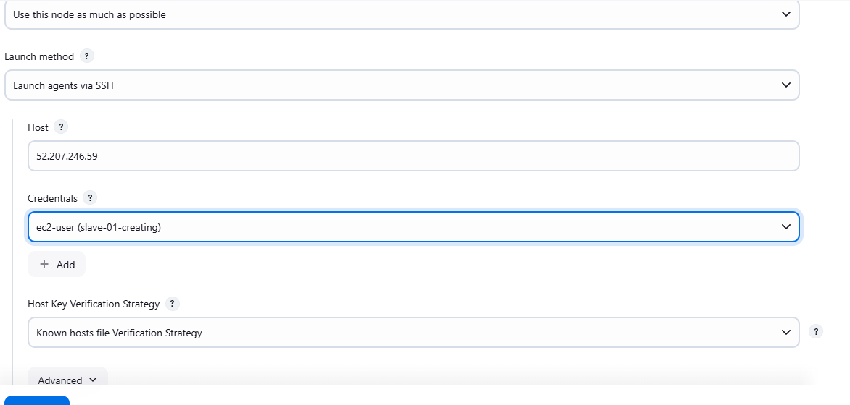

Slave01 has been created And slave -02 as well

Need to change ownership and give permission to the file

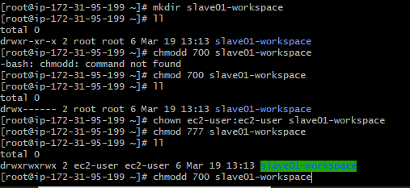

Need to change the root directory

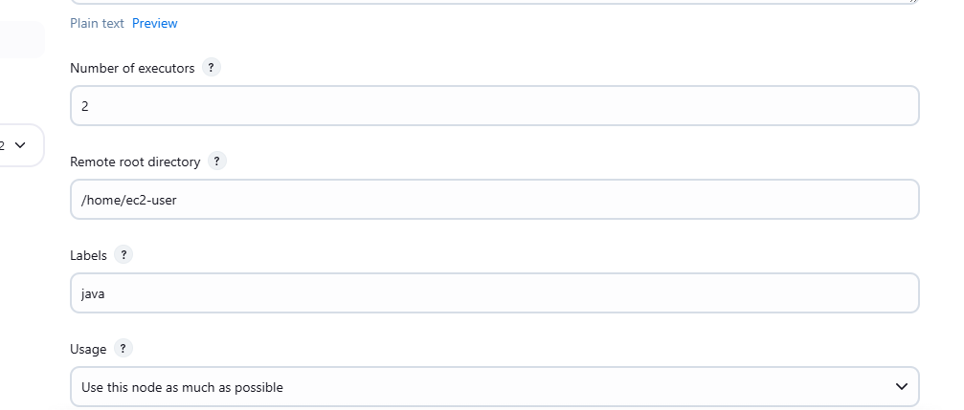

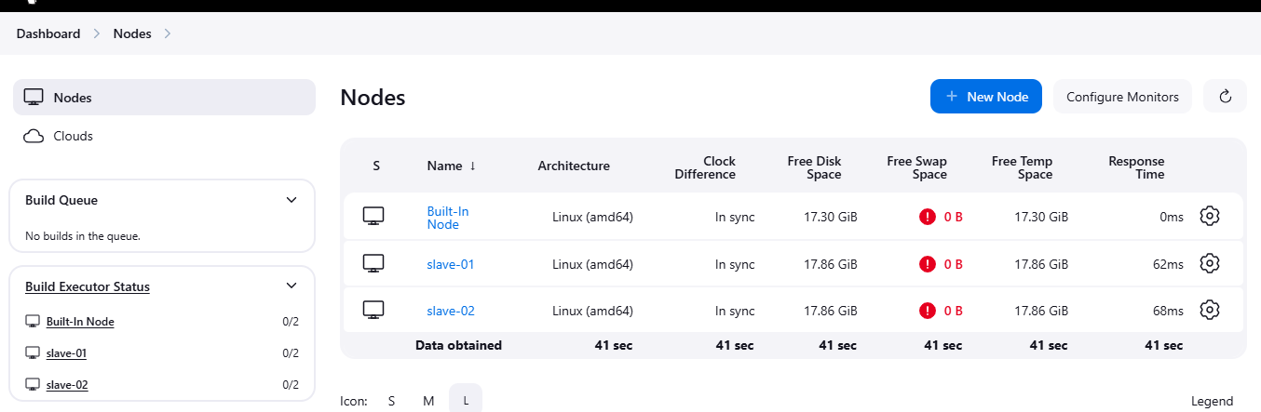

1. Configure webhooks to jenkins job.

Go to github 🡪 select repo –> settings 🡪 webhooks 🡪Add webhooks

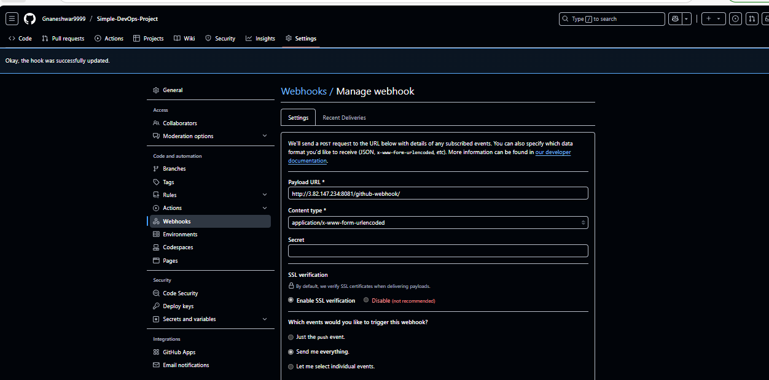 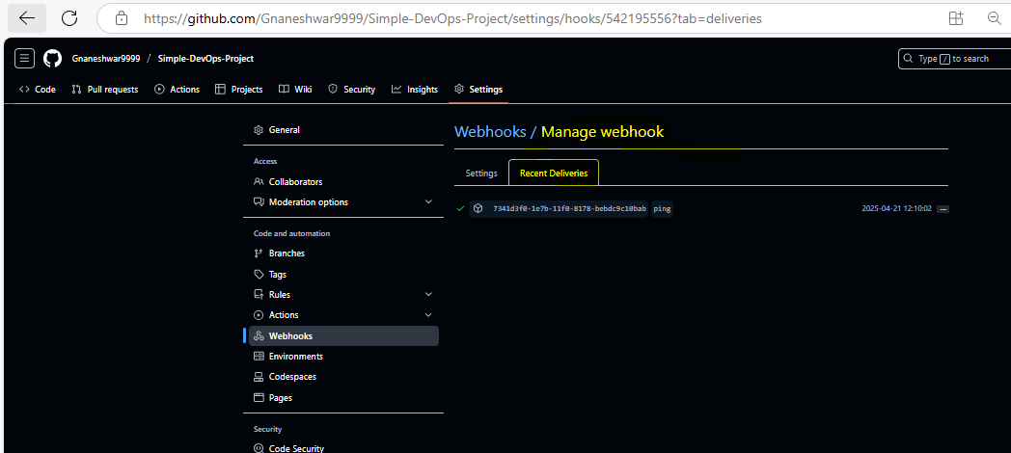

Add the changes in github repo and commit the changes it will automatically trigger to the Jenkins

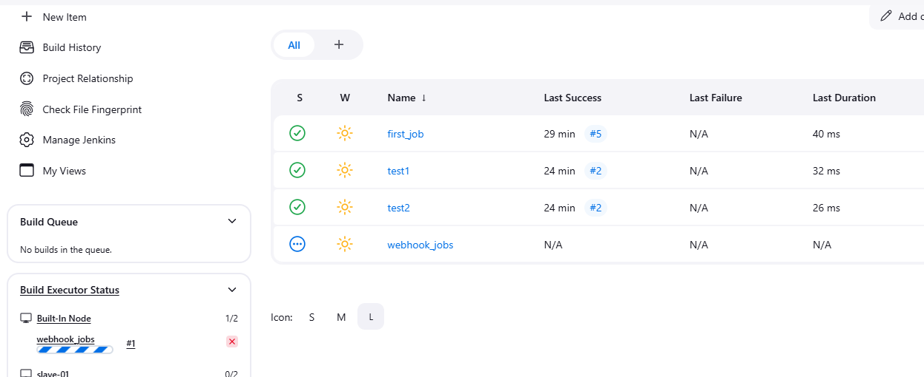

3)Configure poll scm and build periodical options in jenkins job.

Select the options in configure 🡪 poll SCM and take * * * * * and save

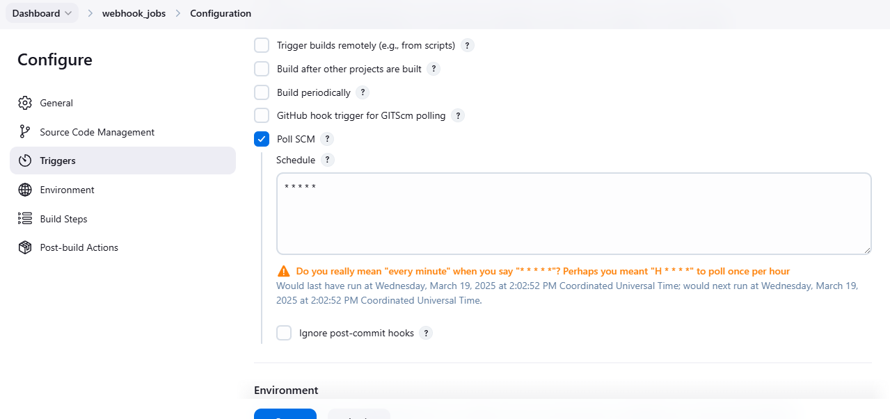

Need to change in the github and it will trigger in the jenkins

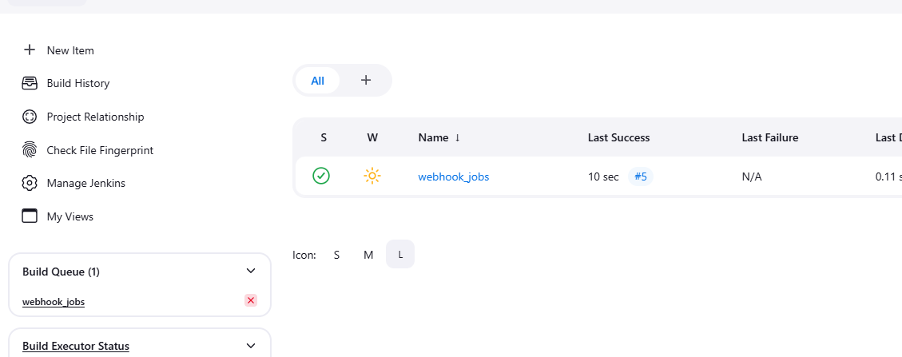

For build periodically we need to select the build periodically and give the * * * * * and save it

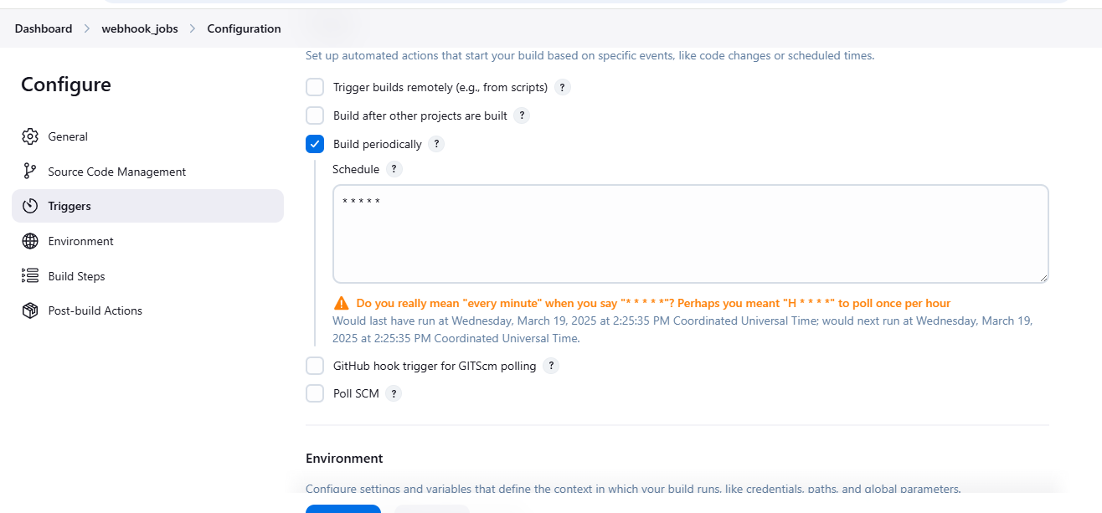

4)Take backup of jenkins server by using bash script.

Creating a directory by using the path cd/var/lib/Jenkins/backup

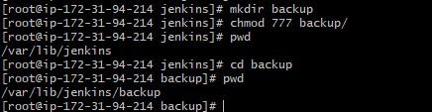

By using vi editor and save this below script and execute the script

**#!/bin/bash  
# Backup directory  
BACKUP_DIR="/backup/jenkins"  
TIMESTAMP=$(date +"%Y-%m-%d_%H-%M-%S")  
BACKUP_FILE="jenkins_backup_$TIMESTAMP.tar.gz"  
# Jenkins home directory  
JENKINS_HOME="/var/lib/jenkins"  
# Days to keep old backups  
RETENTION_DAYS=7  
echo "Starting Jenkins backup..."  
# Stop Jenkins service (optional but safer)  
sudo systemctl stop jenkins  
# Ensure backup directory exists  
mkdir -p "$BACKUP_DIR"  
# Create a compressed backup  
tar -czvf "$BACKUP_DIR/$BACKUP_FILE" "$JENKINS_HOME"  
# Restart Jenkins service**

**sudo systemctl start jenkins  
echo "Backup completed: $BACKUP_DIR/$BACKUP_FILE"  
# Delete old backups  
find "$BACKUP_DIR" -name "jenkins_backup_*.tar.gz" -mtime +  
$RETENTION_DAYS -exec rm -f {} \;  
echo "Old backups older than $RETENTION_DAYS days deleted."**

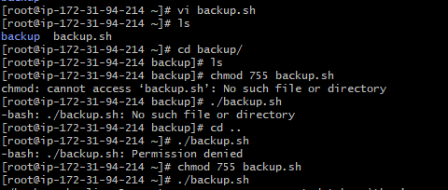

Executing the .backup.sh file

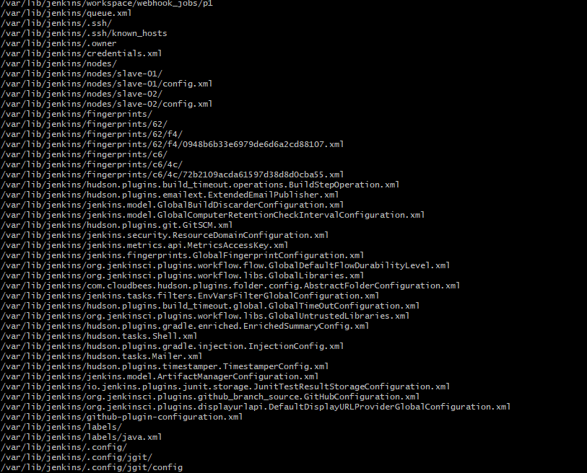

We have created the one tar.gz file backup floder



Untar the file we can see the backup files there

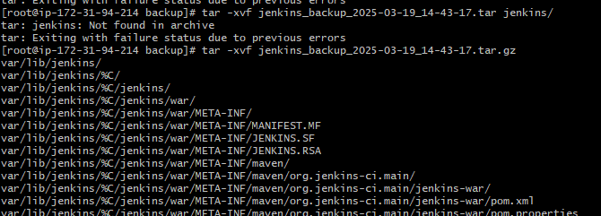



5)Take backup of jenkins using rethin backup plugin.

To take a backup by using the thin backup plugin

We need to install the plugin by using the path

Dashboard🡪manage Jenkins🡪available plugins 🡪thin backup 🡪install

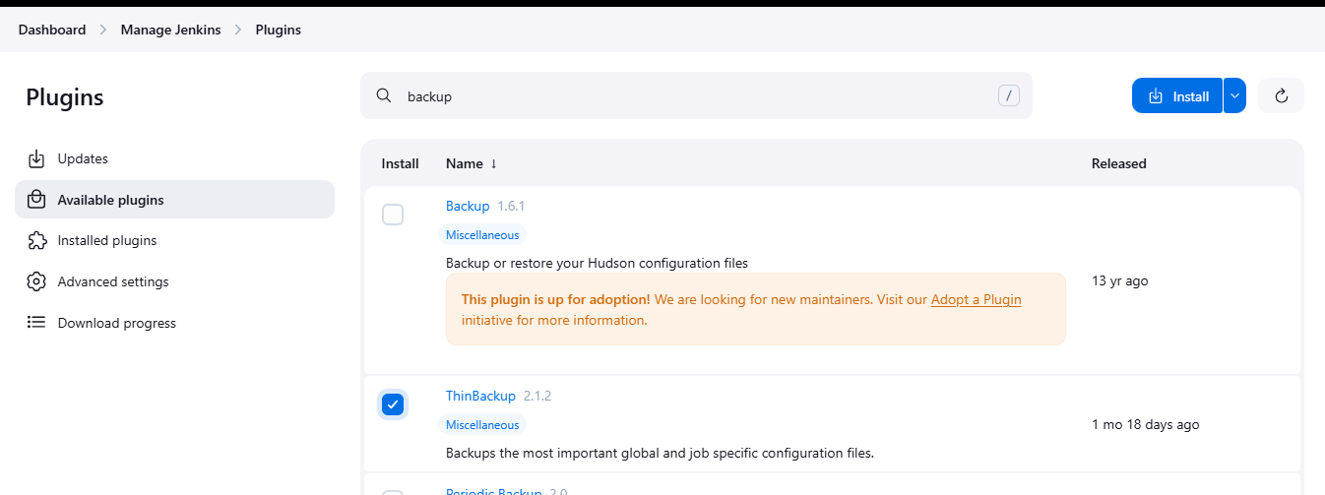

Downloaded the plugins

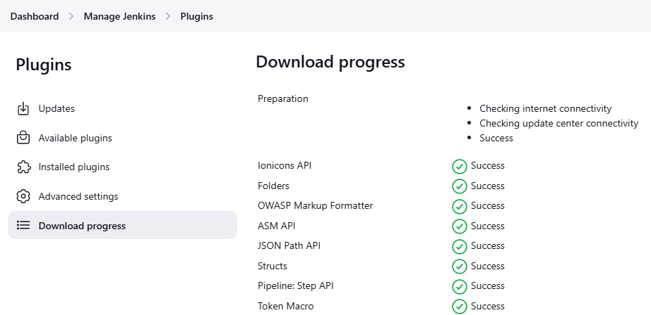

Here we can see the thin backup in the tools and actions

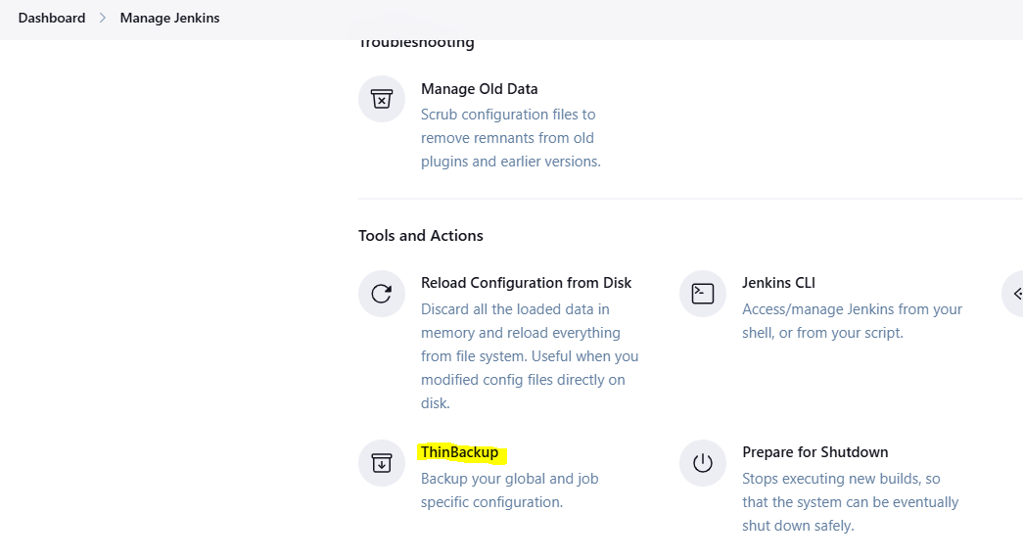

Configure the thin backup

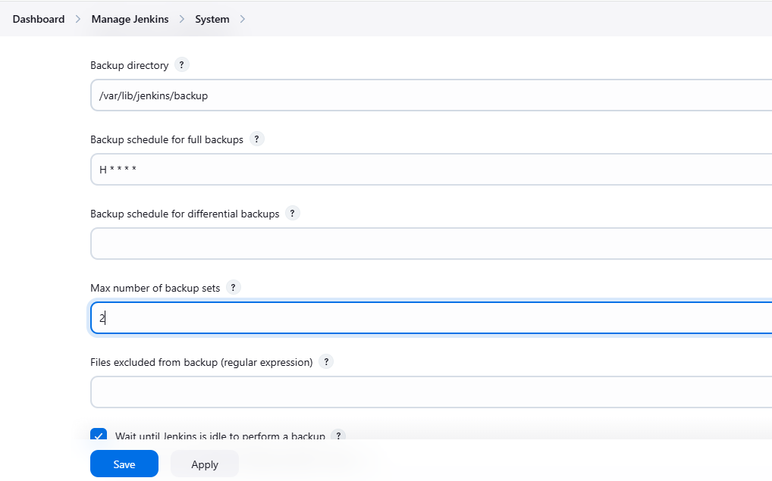

Take bakup now

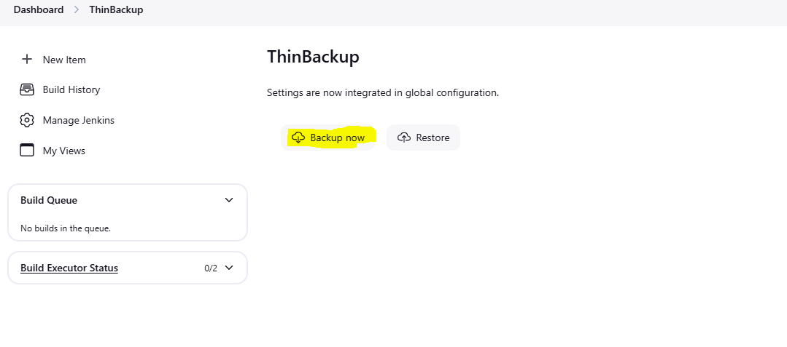

We can see the backup file in cli note

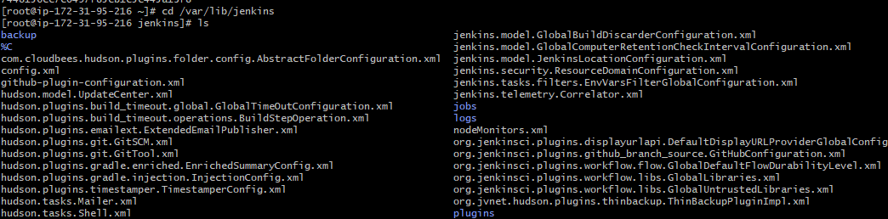

6) Setup a new jenkins server and dump the backup taken in task4.

Create a instance for Jenkins backup and we have a backup file in our master instance

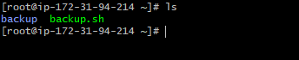

We need to copy pem key file of backup server to master server

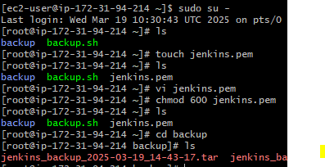

Now use Secure copy

Scp -i pemkey backup(.tar file) ec2-user@backup server ip:/home/ec2-user

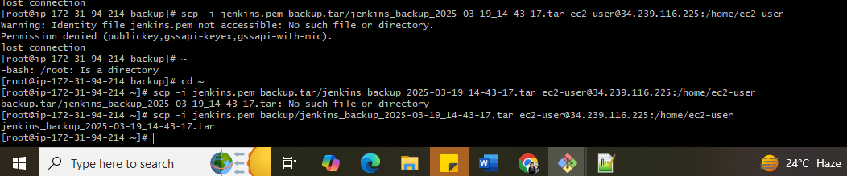

We can see the backup file in backup server as well

